COURSE PREFIX COURSE NUMBER Course Title
Section Number

Instructor Information
Name
Qualifications
Image

Name
Email
Role in the Course
Office Location
Office Hours
Office Phone
Cell Phone
Other contact information
Other contact information
Other contact information
Course Details
Modality: Course Credit:
Course Description
Course Prereqs
Course Meeting Times
Required Texts

Recommended Texts and Other Readings

Computer Hardware & Software Requirements
Computer
Internet Connection

Course Structure

Blackboard Access
To get into this course on Blackboard, you must use a computer that accesses the Internet and that has the appropriate web browsers, Chrome or Firefox.
You can access Blackboard by logging into MySSU and clicking "Blackboard."
Alternately, you can access Blackboard at https://blackboard.shawnee.edu To log in, click on "Sign in with third-party account" and select the Blackboard link from the drop-down menu.
Email
Your SSU email is the official means of electronic means of communication. Please check SSU email often for updates/communications. It is recommended to subscribe to Blackboard Discussion Board Forums to receive prompt notification of activities within forums.

SSU Technical Assistance
If you need technical assistance at any time during the course, please fill out the ITS Get Help Form or email itservice@shawnee.edu with a detailed explanation of the issue. You can also call ITS at 740-351-3538. ITS hours are Mon-Thursday 8:00AM - 5:00PM and Fri 9:00AM - 4:00PM.
Additional Technical Support

Course Goals/ Objectives

Ohio Transfer 36 Learning Outcomes

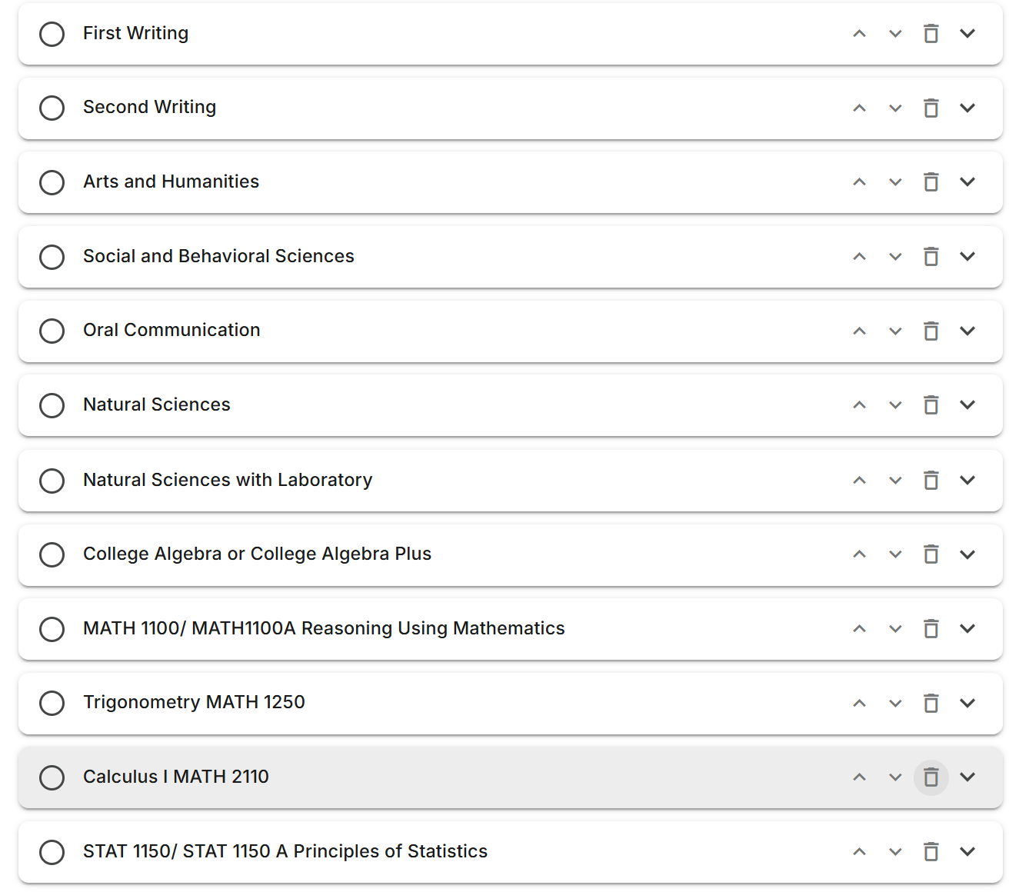

Topic Outline/Schedule

Graded Course Activities

Blackboard Course Activities

General Education Program Assessment

Letter Grade Assignment

Letter Grade | Percentage | Performance
A | 93-100% | Excellent Work
A- | 90-92% | Nearly Excellent Work
B+ | 87-89% | Very Good Work
B | 83-86% | Good Work
B- | 80-82% | Mostly Good Work
C+ | 77-79% | Above Average Work
C | 73-76% | Average Work
C- | 70-72% | Mostly Average Work
D+ | 67-69% | Below Average Work
D | 63-66% | Poor Work
D- | 60-62% | Marginal Work
F | 0-59% | Failing Work

Late and Make Up Work Policy

Other Course Policies and Expectations

Attendance in this Course

Completing Assignments

Understand When You May Drop This Course
Students may drop a class or withdraw with no “WD” grade through the first Friday of a half-session via MySSU or by completing the proper form with the Student Business Center. A refund will occur anytime a student drops an E-campus course during the first five days of the session (7-week session). If an E-campus course is the full semester, the student has two weeks to drop at 100% refund of tuition and fees. If dropping a class, a refund will only result if the total credit hours drops below 12 credit hours. A withdraw after the first Friday will result in a grade of “WD” on the student’s academic record. Withdrawing from courses may affect Title IV student financial aid funds. Please refer to the Financial Aid: Satisfactory Academic Progress (SAP) section of Shawnee’s website.
You may withdraw from a class through the fourth week of a half-session via MySSU or by completing the Registration Add/Drop form from the Student Business Center. Any drops after this date are only by formal appeal to the Registration Appeals Committee.
Please refer to the Registrar’s website for official dates pertaining to each term at: Academic Calendar and Important Dates.
Incomplete Policy
If you are unable to attend class for an extended period of time, you may contact the faculty member responsible for the class to request an incomplete grade. Incompletes must be completed by the agreed upon date or the end of the subsequent semester, if work is not completed the Incomplete will become an F. The Incomplete Policy and Forms may be found here.
University ADA Statement and Religious Accommodations Policy
Copies of these policies may be found here.

SSU’s Title IX Statement
Title IX of the Education Amendments of 1972 is a federal law that prohibits discrimination on the basis of sex in educational programs and activities at institutions that receive federal financial assistance. Sexual harassment, which includes acts of sexual violence, is a form of sex discrimination prohibited by Title IX. Sex discrimination is a continuum of behaviors ranging from sexual harassment and intimidation to sexual assault. Shawnee State University is committed to maintaining a learning environment free from discrimination on the basis of sex, which includes sexual harassment and sexual violence. These acts violate an individual's fundamental rights and personal dignity and will not be tolerated. The University seeks to address sex discrimination, sexual harassment, and sexual violence through education, policy enforcement, and by providing mechanisms for students, faculty, staff and visitors to report concerns or complaints. Prompt corrective measures will be taken to stop sex discrimination, sexual harassment and sexual violence whenever it occurs.
SSU's Academic Honesty Policy & Procedures
Students at Shawnee State University are required to do their own work on all tests and assignments. Any form of cheating may result in your being withdrawn from a particular course or courses and a failing course grade, as well as possible dismissal from the University. Additional information may be found in the Student Conduct Code.
SSU’S Netiquette Policy
Netiquette, or network etiquette, defines appropriate behavior in the online learning environment. The etiquette guidelines that govern behavior when communicating on the Internet is known as netiquette. Netiquette covers not only rules of behavior during discussions, but also guidelines that reflect the unique electronic nature of the medium. The online environment includes any communication that occurs via technology, such as email, discussion boards, chat rooms, websites, blogs, wikis, text messages and instant messaging.
Security
Don’t share your password with anyone or change your password if you think someone else might know it. Always logout when you are finished using the system
Guidelines
- Treat instructor and classmates with respect in online communication
- Use clear and concise language
- Remember that all college level communication should have correct spelling and grammar
- Avoid slang terms such as “idk” and texting abbreviations such as “u” instead of “you”
- Avoid using the caps lock feature AS IT CAN BE INTERPRETED AS YELLING
- Be cautious when using humor or sarcasm it does not always transfer in email or discussion and might sound offensive
- Be careful with personal information
- Only send communication as yourself and do not do so anonymously or use forged messages from others’ email, Blackboard or other College managed communication
Email and Discussion Board
- Use a descriptive subject line such as “last name,” class & section
- Include your name in your message
- Make posts that are on topic and within scope of course material
- Take your posts seriously and review and edit your posts before sending
- Be as brief as possible while still making a thorough comment
- Always give proper credit when referencing or quoting another source
- Avoid short, generic replies such as, “I agree.” Include why you agree or add to the point
- Always be respectful of others’ opinions even when they differ from your own
- When you disagree with someone you should express your differing opinion in a respectful way
- Do not make personal or insulting remarks
- Be open-minded
Artificial Intelligence Policy for This Course

